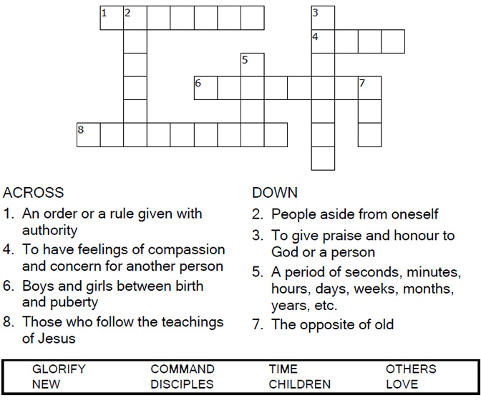

Copyright © Sermons4Kids, Inc.
May be reproduced for Ministry Use

Children’s Worship Bulletin

A New Commandment

John 13:31-35

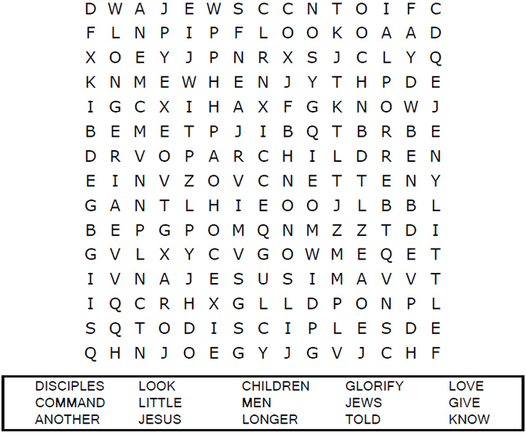
St. Paul’s UCC
301 W. Penn Avenue
Robesonia, PA 19551
610-621-5770

Connect the dots to complete the picture.

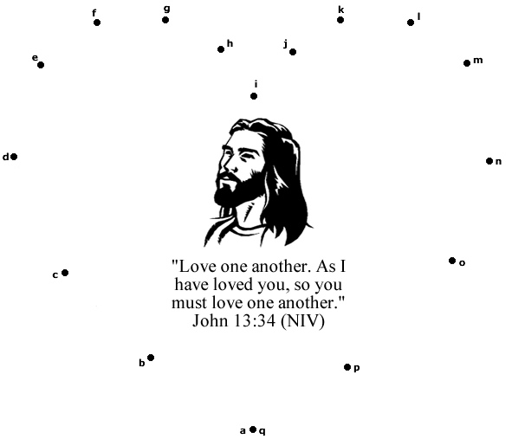



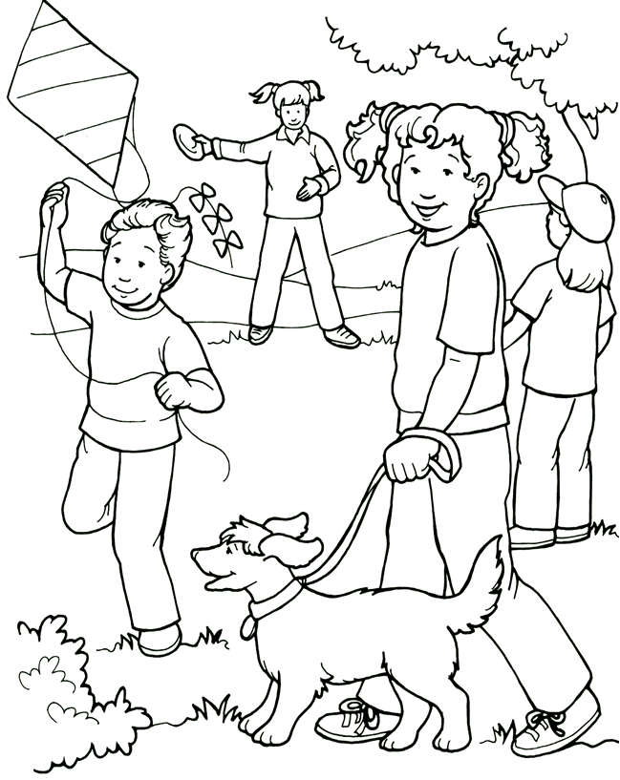
Love one another as I have loved you.

From Thru-the-Bible Coloring Pages for Ages 4-8. © 1986,1988 Standard Publishing.
Used by permission. Reproducible Coloring Books may be purchased from
Standard Publishing, www.standardpub.com, 1-800-543-1301.

