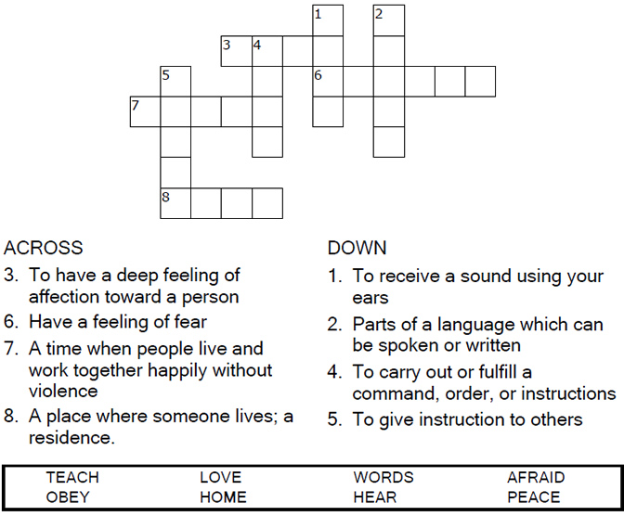
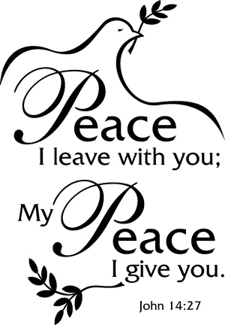
Copyright © Sermons4Kids, Inc.
May be reproduced for Ministry Use

Children’s Worship Bulletin

Peace of Mind and Heart

John 14:23-29

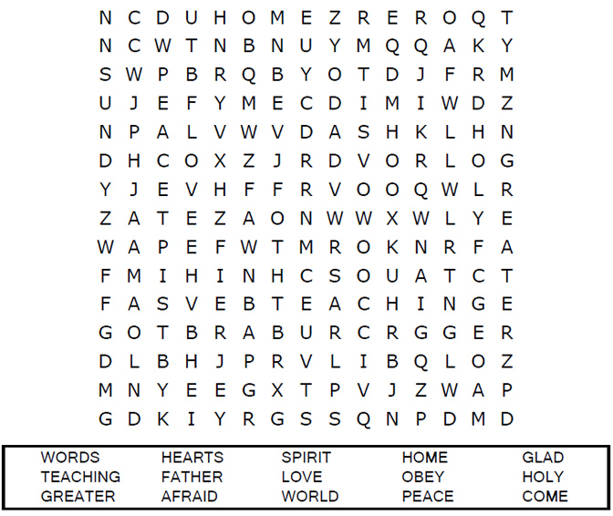
St. Paul’s UCC
301 W. Penn Avenue
Robesonia, PA 19551
610-621-5770

Connect the dots to complete the picture.

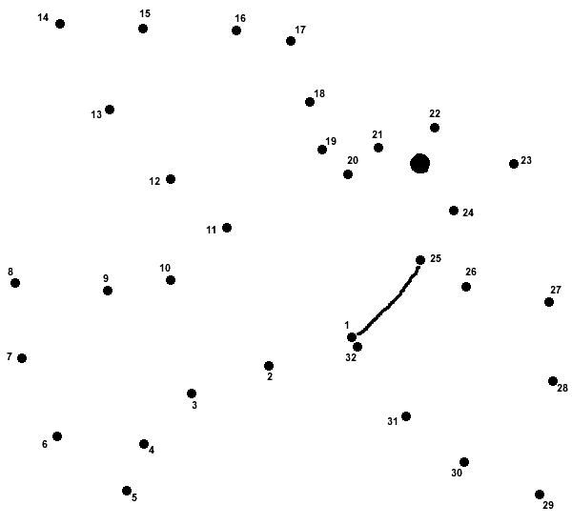

But the Counselor, the Holy Spirit, whom the Father will
send in my name, will teach you all things and will
remind you of everything I have said to you.
John 14:26 (NIV)



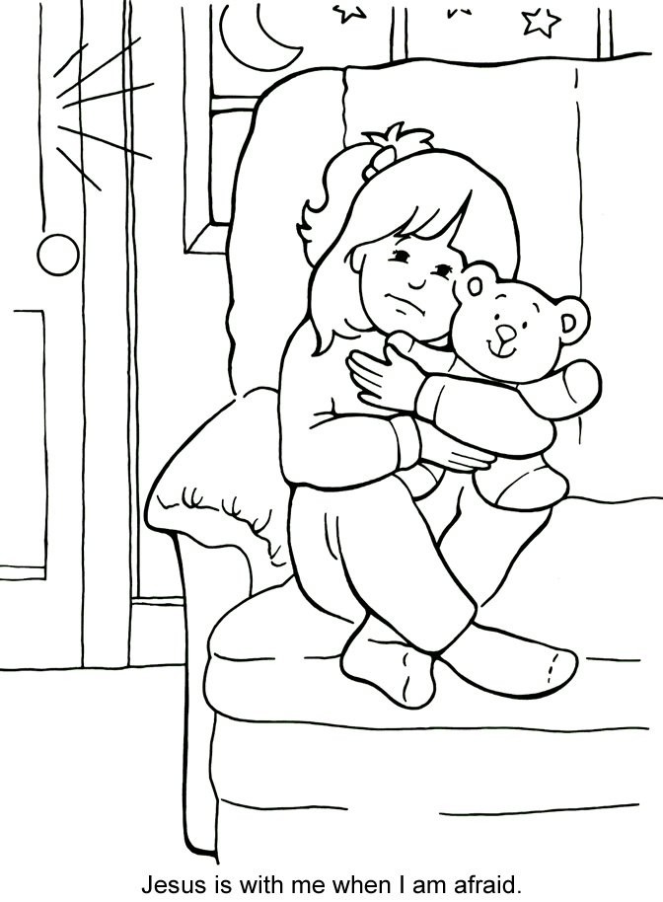

From Thru-the-Bible Coloring Pages for Ages 4-8. © Standard Publishing.
Used by permission. Reproducible Coloring Books may be purchased from
Standard Publishing, www.standardpub.com, 1-800-323-7543.

