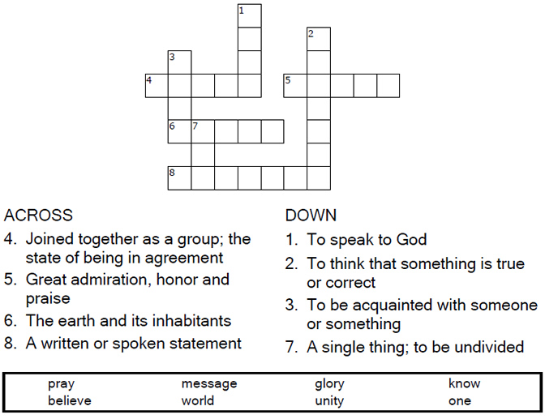

Copyright © Sermons4Kids, Inc.
May be reproduced for Ministry Use

Children’s Worship Bulletin

Jesus Prays for All Believers

John 17:20-26

St. Paul’s UCC
301 W. Penn Avenue
Robesonia, PA 19551
610-621-5770

Use the following colors to reveal the subject.

1 – blue 2 – yellow 3 – green
4 – orange 5 – red 6 - purple



I pray that they will all be one, just as you and I are
one—as you are in me, Father, and I am in you.
John 17:21a (NLT)

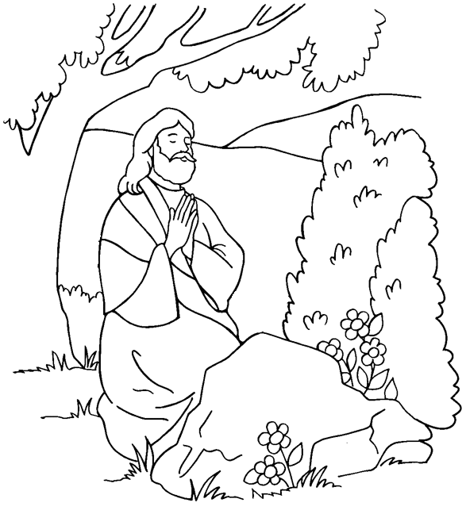

Jesus Prays for All Believers

From Thru-the-Bible Coloring Pages for Ages 4-8. © 1986,1988 Standard Publishing.
Used by permission. Reproducible Coloring Books may be purchased from
Standard Publishing, www.standardpub.com, 1-800-323-5473.

