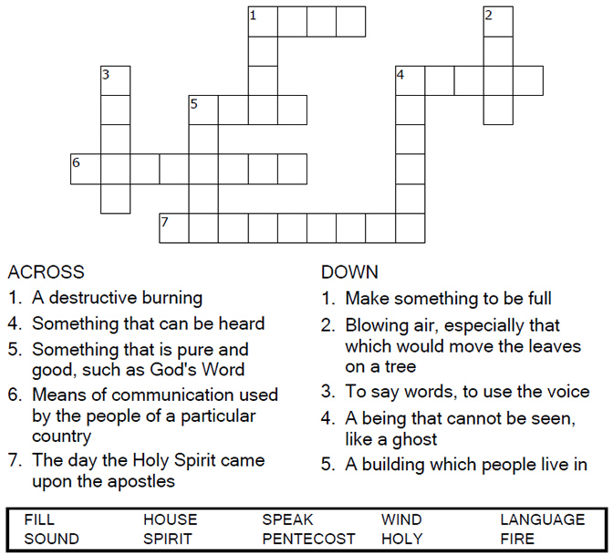
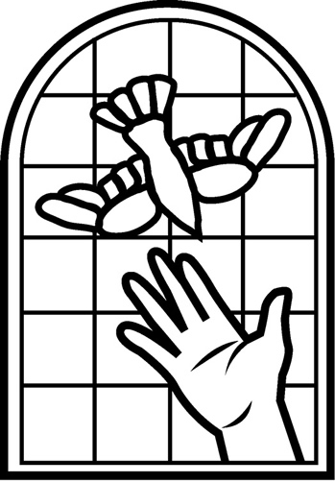

Copyright © Sermons4Kids, Inc.
May be reproduced for Ministry Use
Children’s Worship Bulletin

The Day of Pentecost

Acts 2:1-21

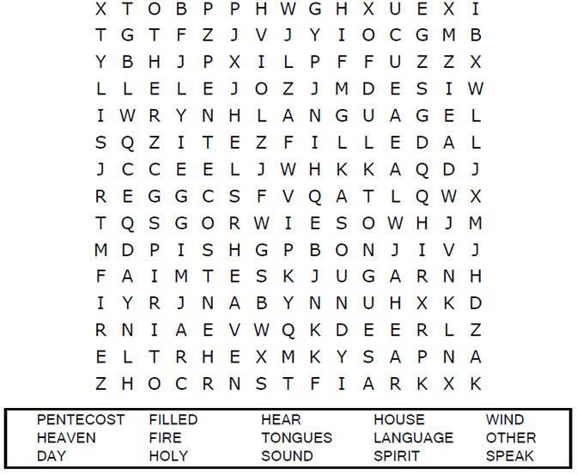
St. Paul’s UCC
301 W. Penn Avenue
Robesonia, PA 19551
610-621-5770

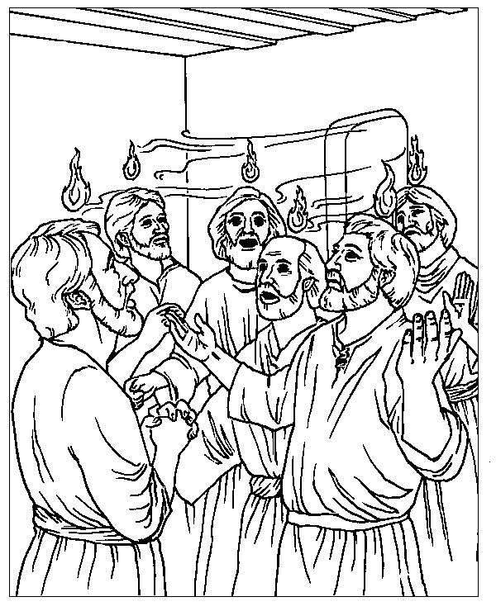
The Day of Pentecost
Acts 2

Thru-the-Bible Coloring Pages for Ages 4-8. © 1986,1988 Standard Publishing.
Used by permission. Reproducible Coloring Books may be purchased from
Standard Publishing, www.standardpub.com, 1-800-323-5473.

Each number represents a letter of the alphabet. Substitute the
correct letter for the numbers to reveal the coded words.

