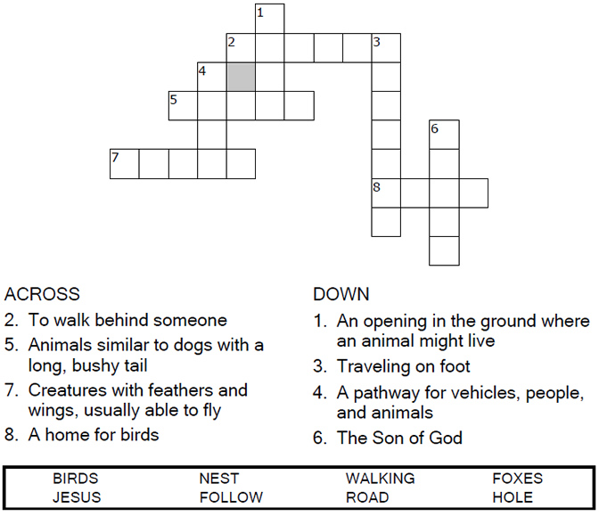
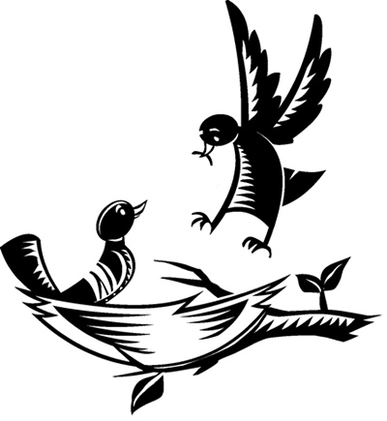
Copyright © Sermons4Kids, Inc.
May be reproduced for Ministry Use

Children’s Worship Bulletin

Hold on to Jesus

Luke 9:56-62

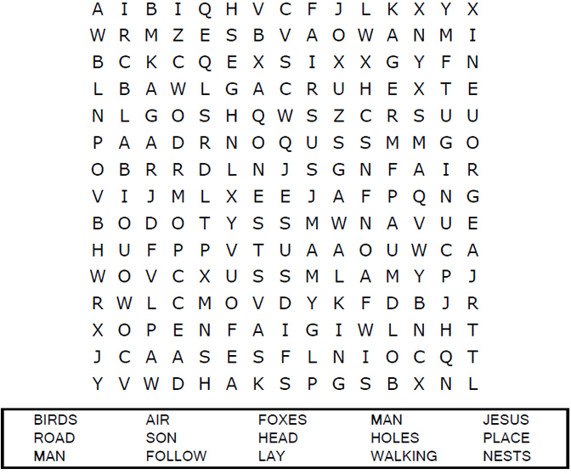
United Church of Christ
301 West Penn Avenue
Robesonia, PA 19551
610-621-5770

Connect the dots to complete the picture.

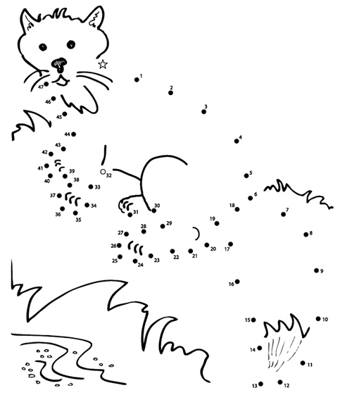

Jesus replied, "Foxes have holes and birds of the air have nests,
but the Son of Man has no place to lay his head."
Luke 9:58 (NIV)
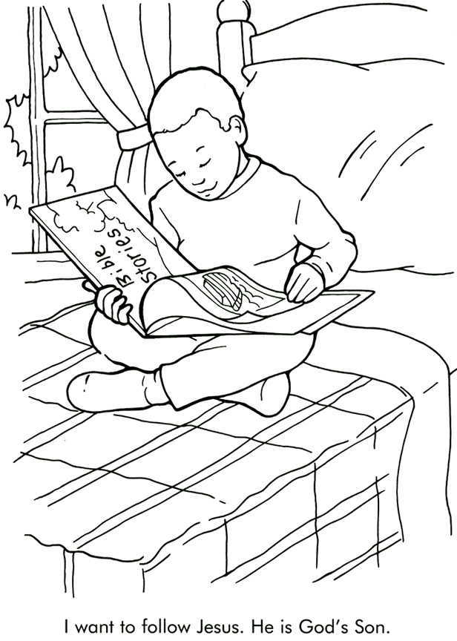

From Thru-the-Bible Coloring Pages for Ages 4-8. © 1986,1988 Standard Publishing.
Used by permission. Reproducible Coloring Books may be purchased from
Standard Publishing, www.standardpub.com, 1-800-543-1301.

