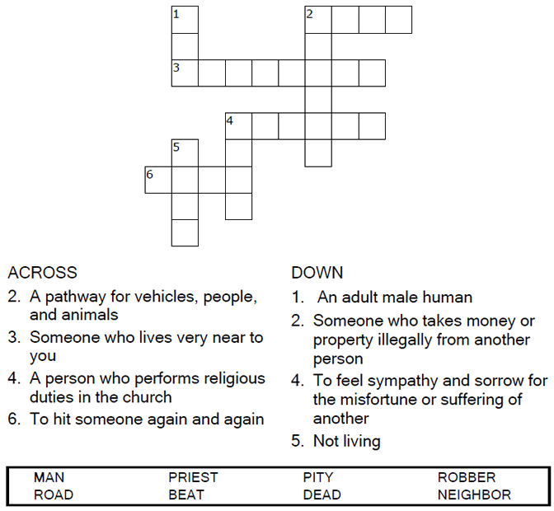

Copyright © Sermons4Kids, Inc.
May be reproduced for Ministry Use

Children’s Worship Bulletin

Parable of the Good Samaritan

Luke 10:25-37

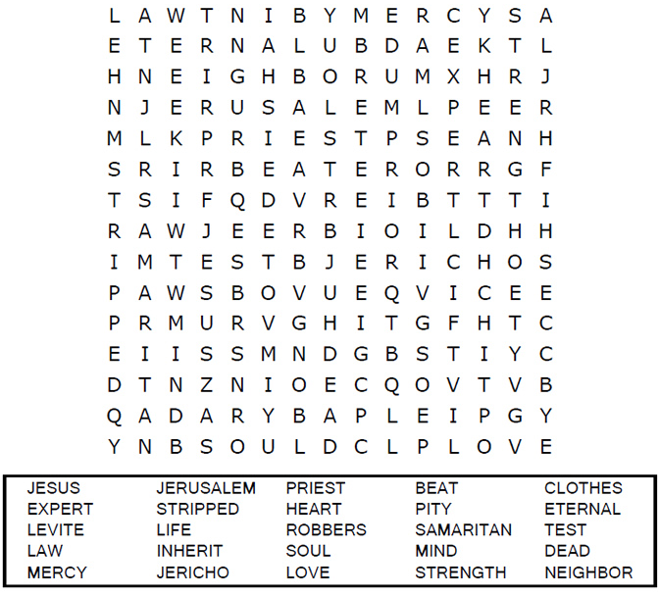

Each number represents a letter of the alphabet. Substitute
the correct letter for the numbers to reveal the coded words.

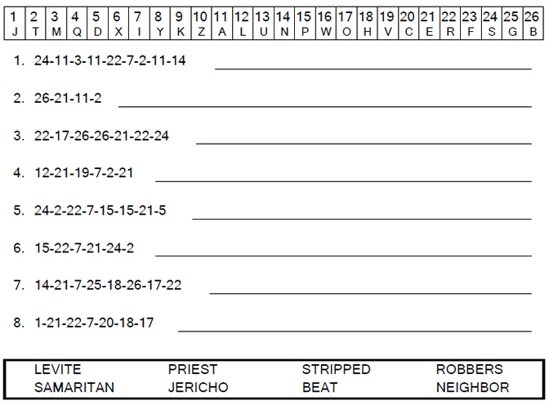
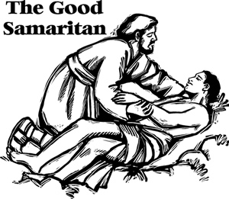

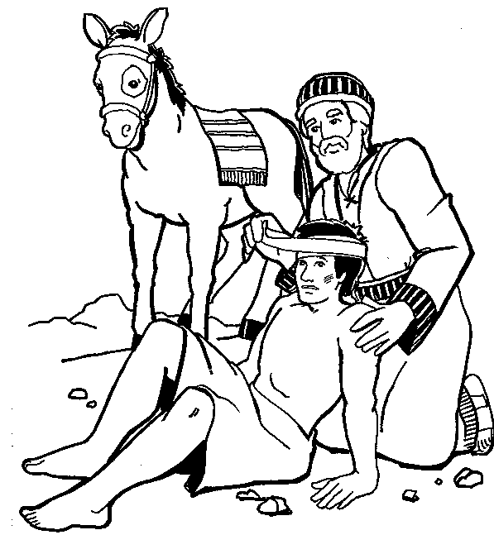

"Which of these three do you think was a neighbor
to the man who fell into the hands of robbers?"
Luke 10:36

