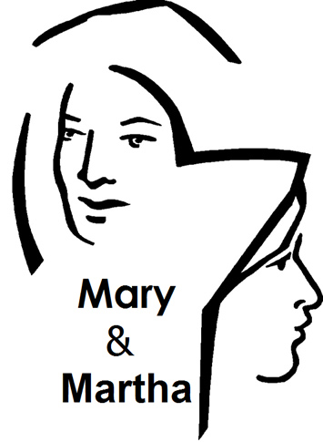

Copyright © Sermons4Kids, Inc.
May be reproduced for Ministry Use

Children’s Worship Bulletin

Mary & Martha

Luke 10:38-42

United Church of Christ
301 West Penn Avenue
Robesonia, PA 19551
610-621-5770

Each number represents a letter of the alphabet. Substitute
the correct letter for the numbers to reveal the coded words.



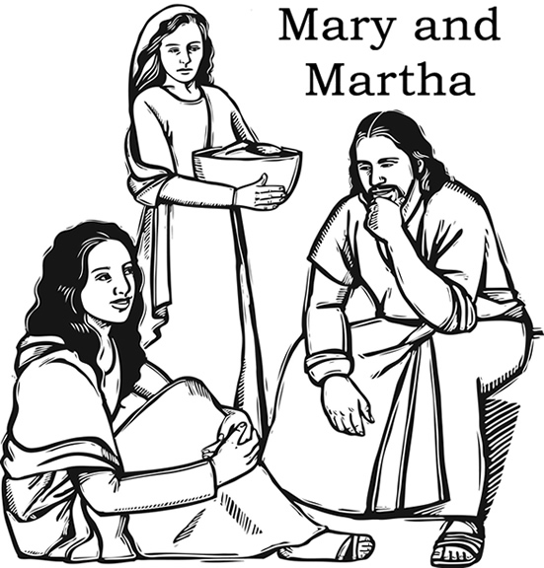

Jesus visits in the home of Mary and Martha.
Luke 10:38:42

