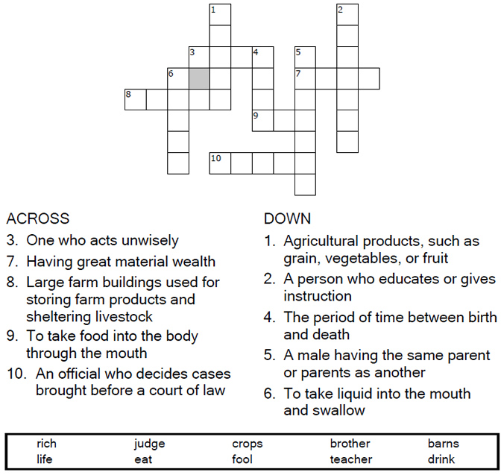


Copyright © Sermons4Kids, Inc.
May be reproduced for Ministry Use
Children’s Worship Bulletin

Parable of the Rich Fool

Luke 12:13-21

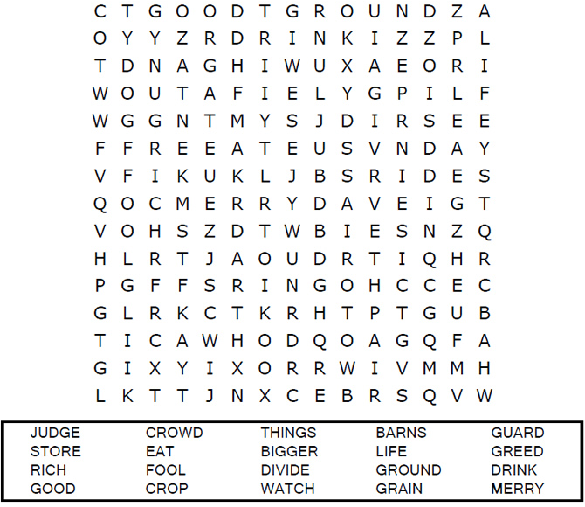

Each number represents a letter of the alphabet. Substitute
the correct letter for the numbers to reveal the coded words.
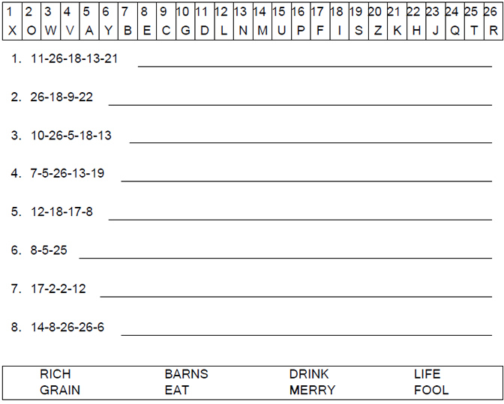

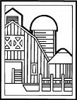

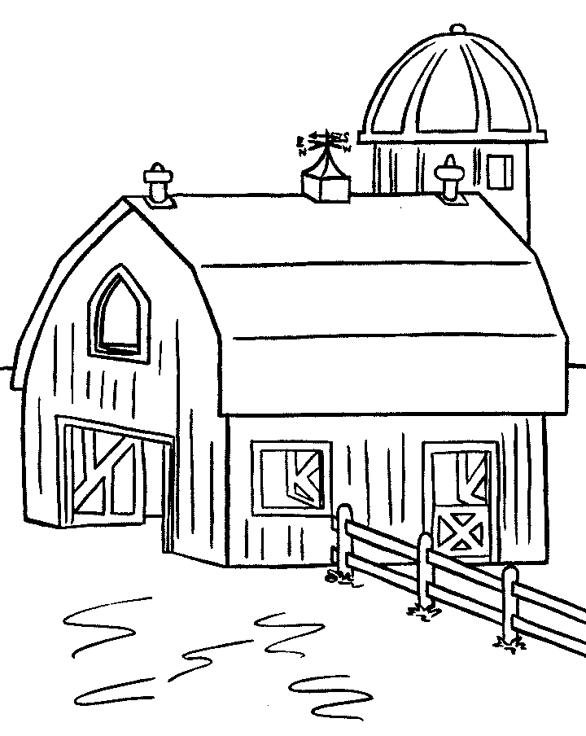
The Parable of the Rich Fool

"Then he said, 'This is what I'll do. I will tear down my barns
barns and build bigger ones, and there I will store
all my grain and my goods.’”
Luke 12:18 (NIV)

