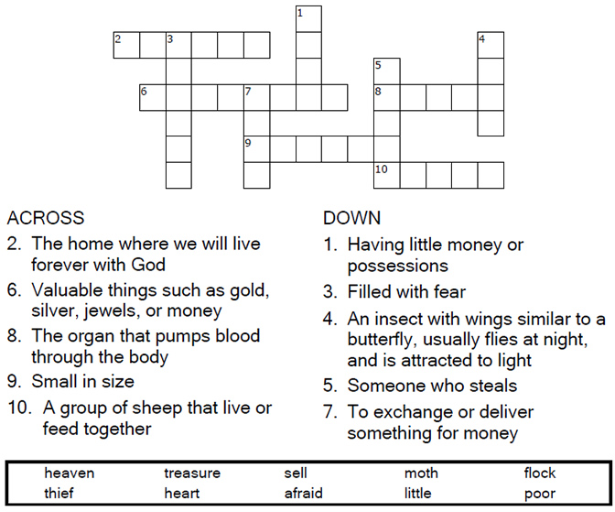


Copyright © Sermons4Kids, Inc.
May be reproduced for Ministry Use
Children’s Worship Bulletin

Treasures in Heaven

Luke 12:32-34

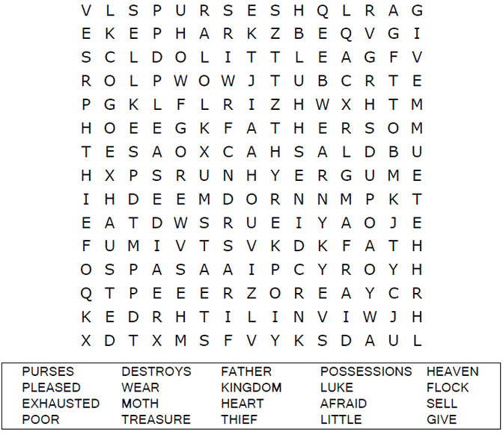
United Church of Christ
301 W. Penn Avenue
Robesonia, PA 19551
610-621-5770

Each number represents a letter of the alphabet. Substitute
the correct letter for the numbers to reveal the coded words.
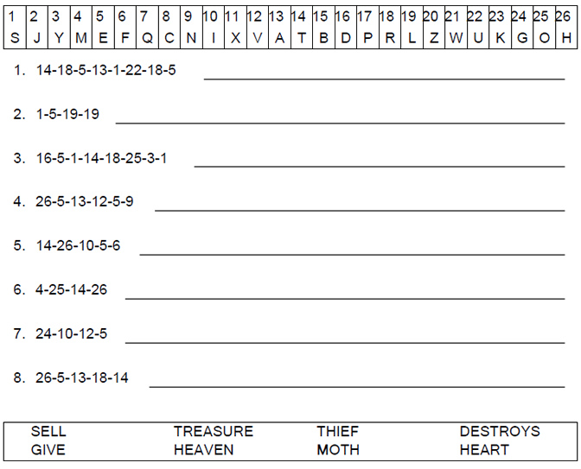



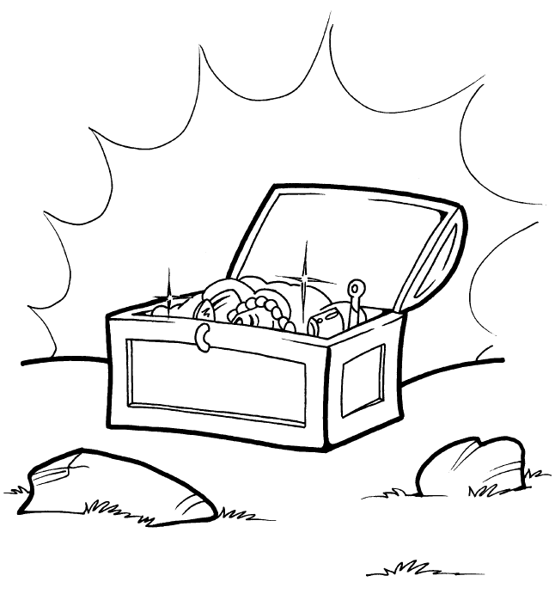
Treasures in Heaven

Provide purses for yourselves that will not wear out, a
treasure in heaven that will not be exhausted, where
no thief comes near and no moth destroys.
Luke 12:33b-34 (NIV)

