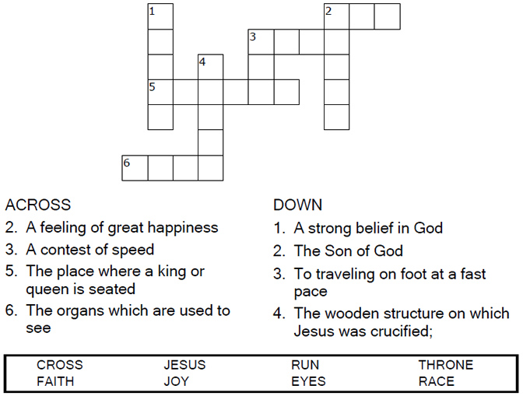
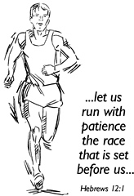

Copyright © Sermons4Kids, Inc.
May be reproduced for Ministry Use
Children’s Worship Bulletin

Run the Race

Hebrews 12:1-2

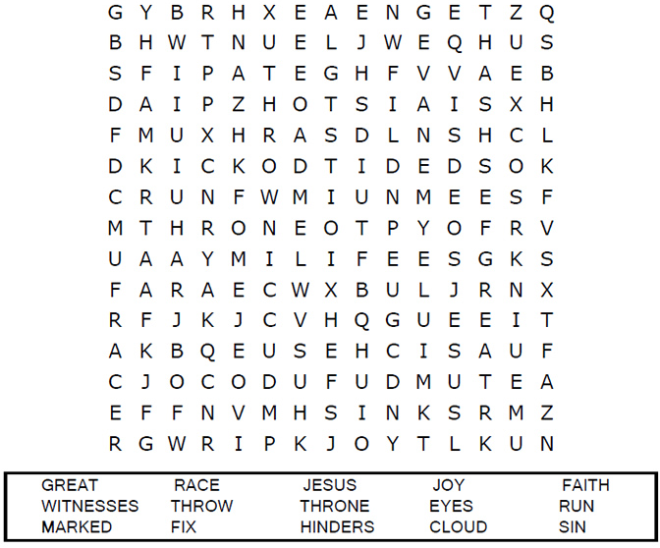
United Church of Christ
301 W. Penn Avenue
Robesonia, PA 19551
610-621-5770

Each number represents a letter of the alphabet. Substitute
correct letter for the numbers to reveal the coded words.
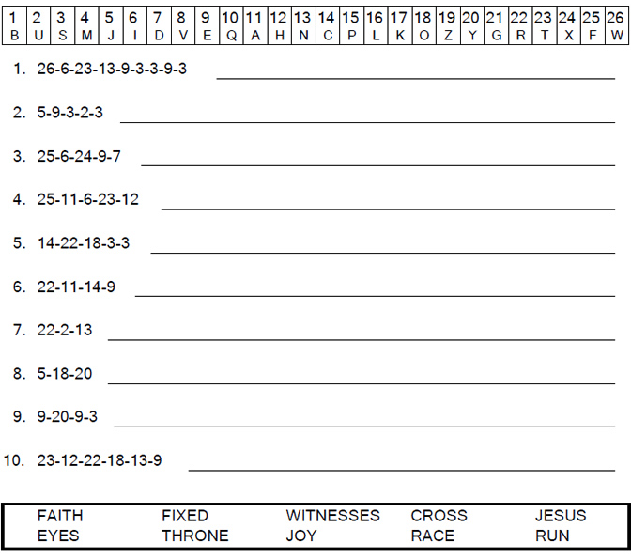
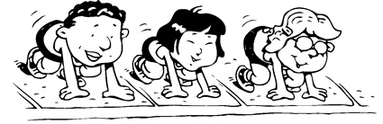

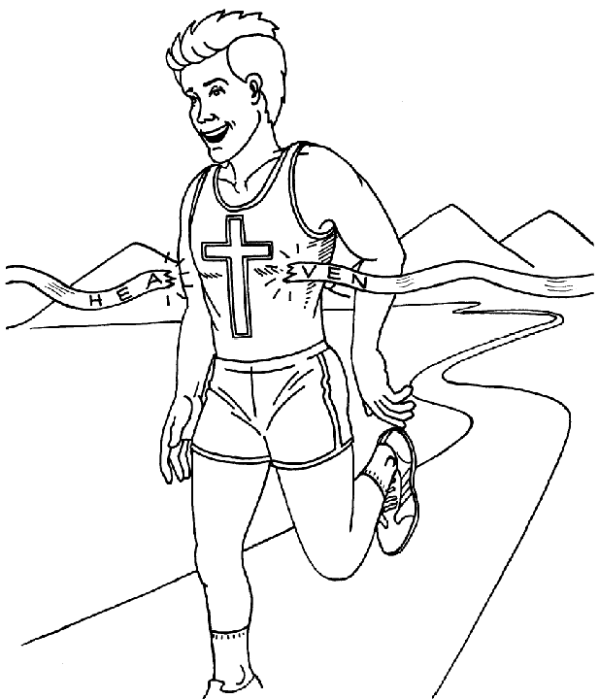

Let us run with perseverance the race that
God has set before us.
Hebrews 12:1b (NIV)

