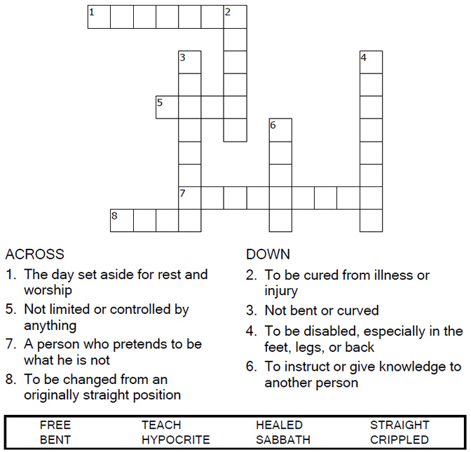


Copyright © Sermons4Kids, Inc.
May be reproduced for Ministry Use
Children’s Worship Bulletin

Jesus Heals on the Sabbath

Luke 13:10-17

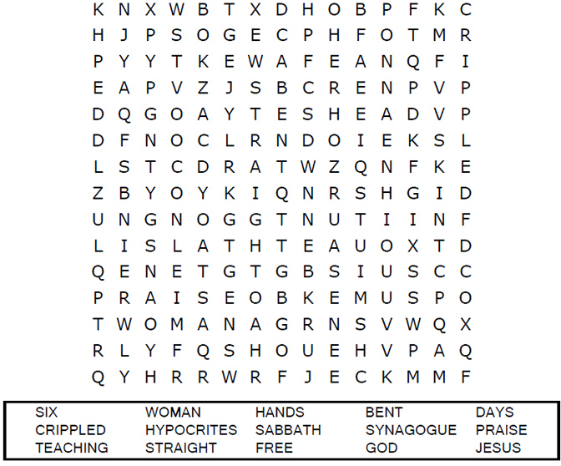
United Church of Christ
301 W. Penn Avenue
Robesonia, PA 19551
610-621-5770

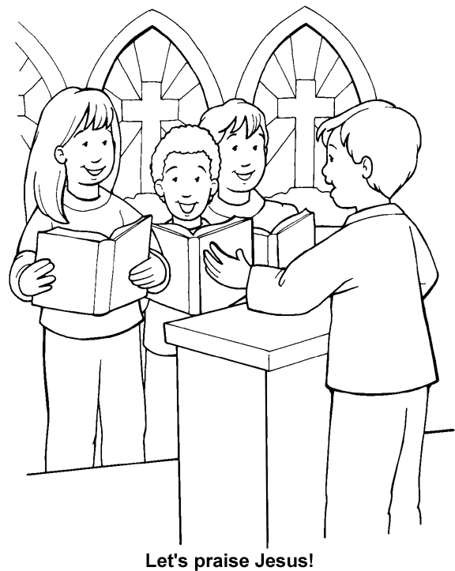
Image from Thru-the-Bible Coloring Pages for Ages 4-8. © 1986,1988 Standard Publishing.
Used by permission. Reproducible Coloring Books may be purchased from
Standard Publishing, www.standardpub.com, 1-800-543-1301.
