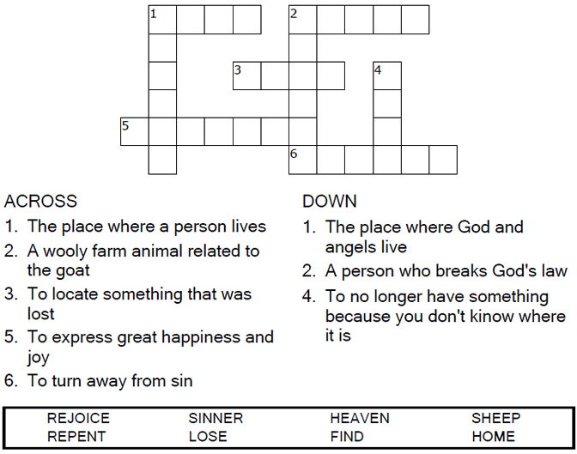
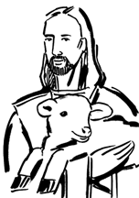

Copyright © Sermons4Kids, Inc.
May be reproduced for Ministry Use
Children’s Worship Bulletin

The Lost Sheep

Luke 15:1-7

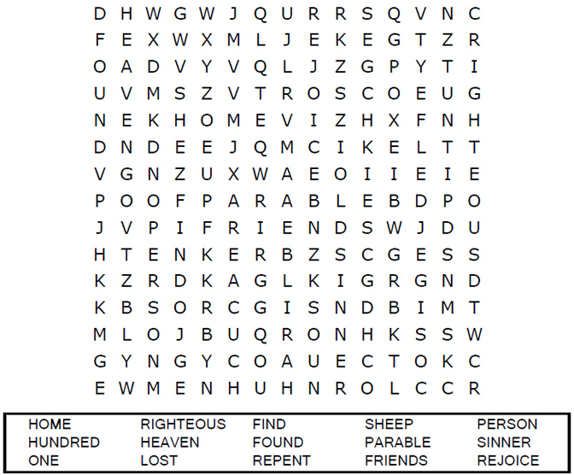
United Church of Christ
301 West Penn Avenue
Robesonia, PA
610-621-5770

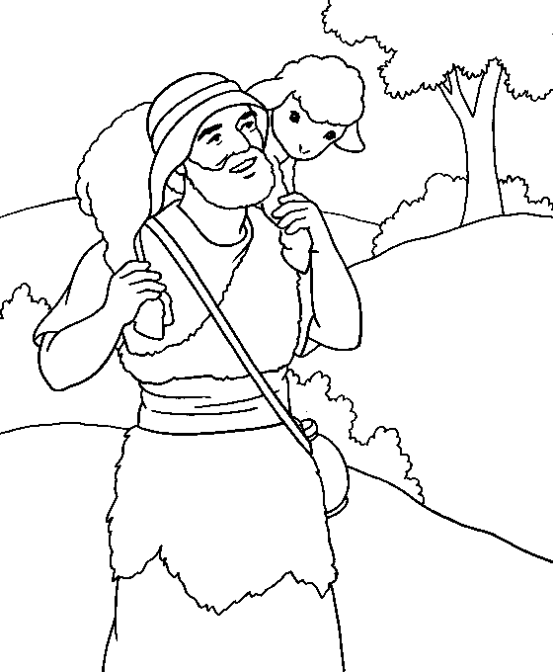

The Parable of the Lost Sheep

Each number represents a letter of the alphabet. Substitute
the correct letter for the numbers to reveal the coded words.

