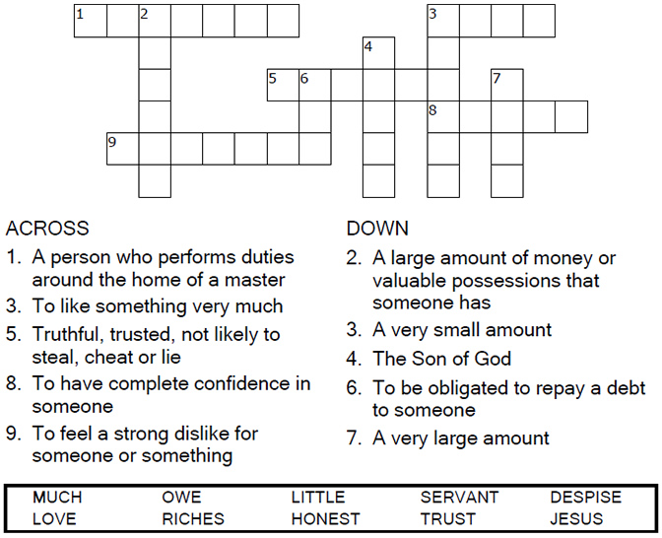


Copyright © Sermons4Kids, Inc.
May be reproduced for Ministry Use
Children’s Worship Bulletin

The Dishonest Manager

Luke 16:1-13

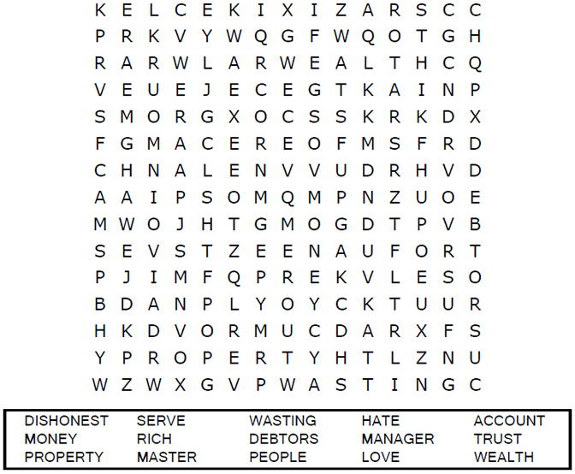
United Church of Christ
301 W. Penn Avenue
Robesonia, PA 19551
610-621-5770

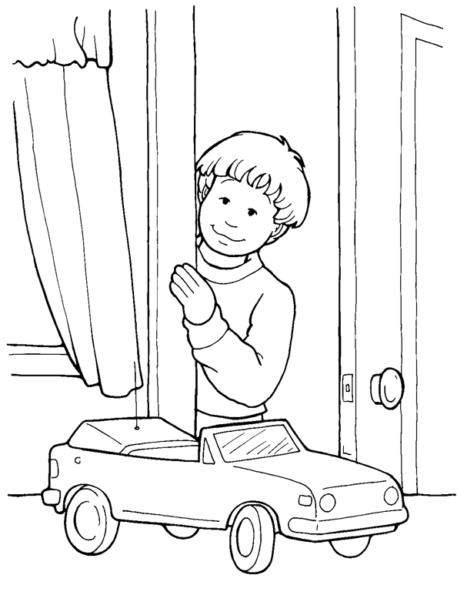
I will follow Jesus when I am tempted to do wrong.
From Thru-the-Bible Coloring Pages for Ages 4-8. © Standard Publishing.
Used by permission. Reproducible Coloring Books may be purchased from
Standard Publishing, www.standardpub.com, 1-800-323-7543

Each number represents a letter of the alphabet. Substitute
correct letter for the numbers to reveal the coded words.

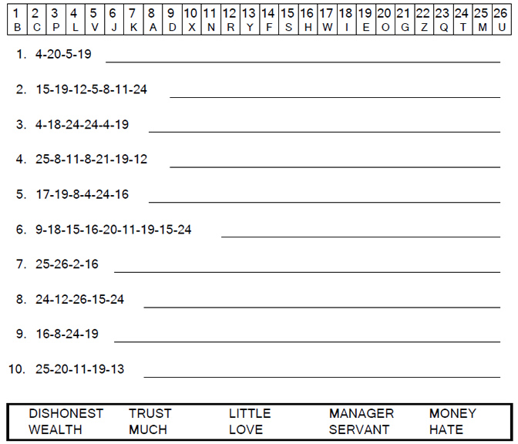


“Whoever can be trusted with very little can also be trusted with much, and whoever is dishonest with very little will
also be dishonest with much.”
Luke 16:10

