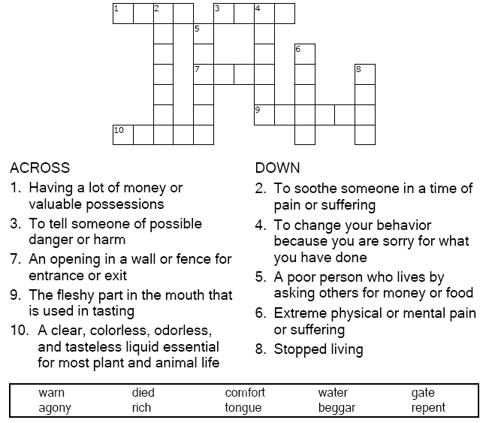
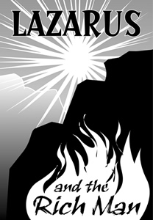

Copyright © Sermons4Kids, Inc.
May be reproduced for Ministry Use

Children’s Worship Bulletin

The Rich Man and Lazarus

Luke 16:19-31

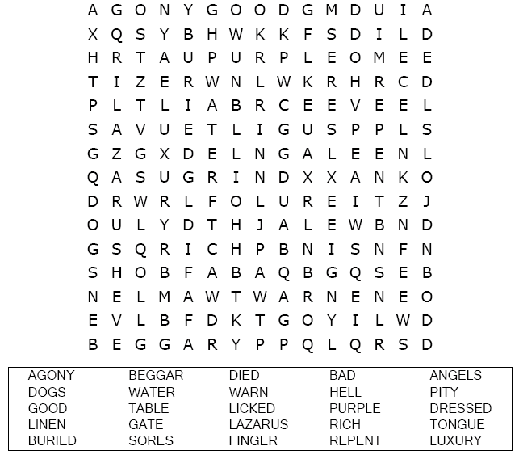
United Church of Christ
301 West Penn Avenue
Robesonia, PA 19551
610-621-5770

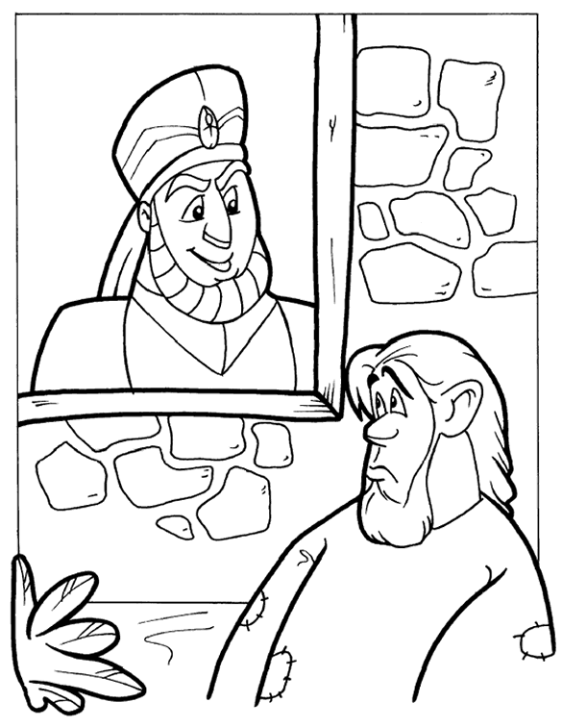
The Rich Man and Lazarus
Copyright © CalvaryCurriculum.com
Used by Permission

Choose the word that best fits the definition.

