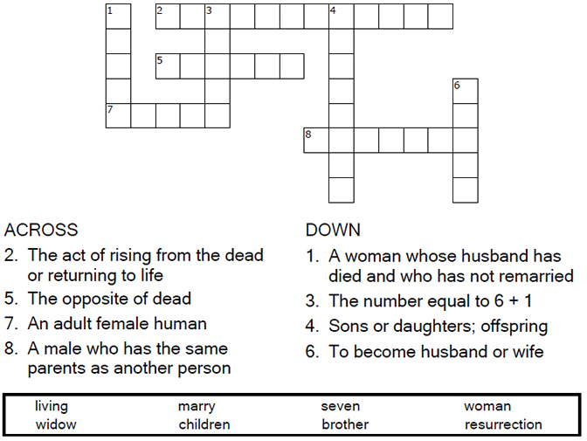
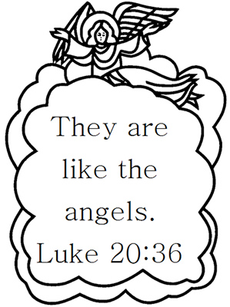

Copyright © Sermons4Kids, Inc.
May be reproduced for Ministry Use
Children’s Worship Bulletin

Jesus and the Sadducees

Luke 20:27-38

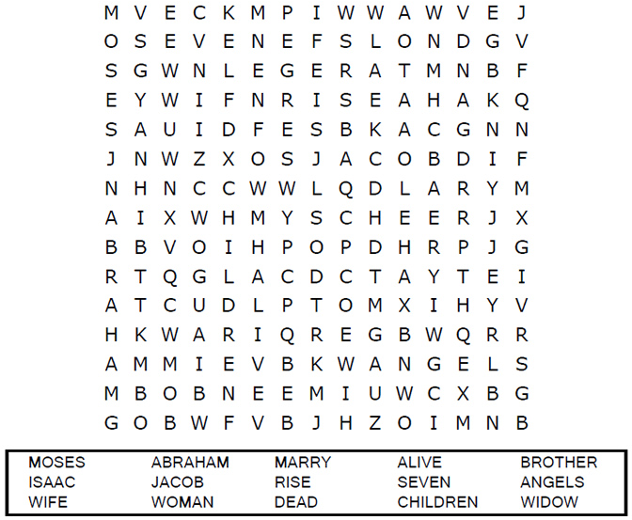

United Church of Christ
301 W. Penn Avenue
Robesonia, PA 19551
610-621-5770

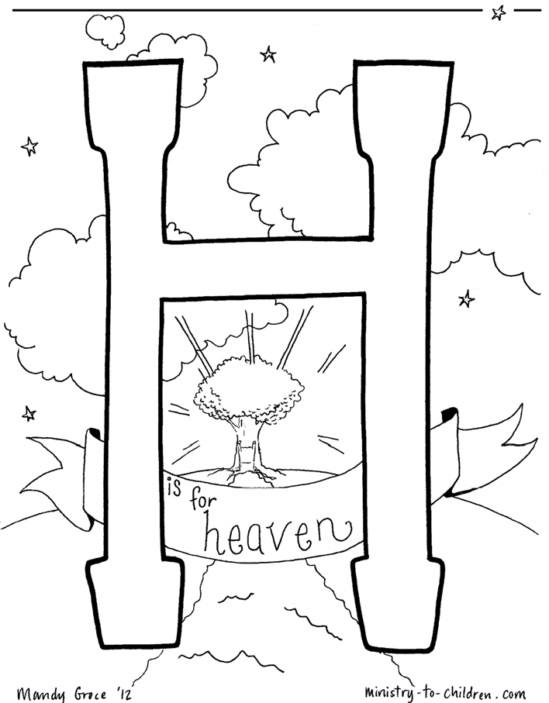

ministry-to-children.com
Used by permission

Each number represents a letter of the alphabet. Substitute
the correct letter for the numbers to reveal the coded words.

