Preschool Crafts for Kids* (easypreschoolcraft.blogspot.com)
Hanging Spiral Snake Craft
This is a nice looking paper snake craft you can hang up and watch twirl around.
Materials:
- green construction paper (alternatively, use a paper plate and paint it green.)
- scissors
- crayons
- string

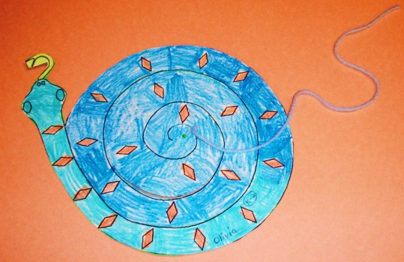
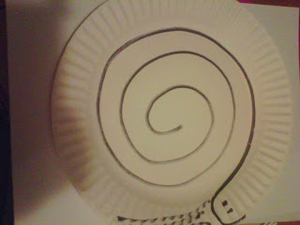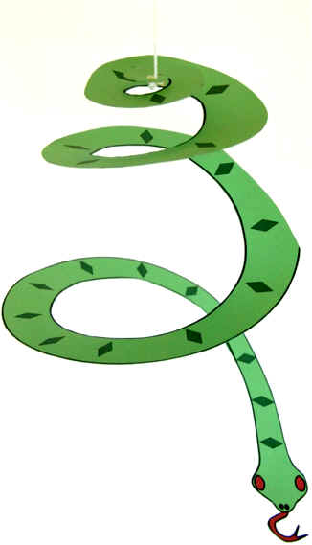
Directions:

- Using the template below or free hand, draw a spiral on green or other color construction paper. Personally, I think it's easier to draw on a paper plate, but you have to paint it first.
- Cut out the spiral along the lines.
- Decorate your snake.
- Poke a hole in the end at the middle of the spiral and tie a string to hang up.

I've seen this craft done with the head hanging down or with the tail hanging down. I think it makes more sense that the head is at the bottom, but you can do it either way.

